**Lab – 6**

**Team**

**18mis7250 – Amit**

**18mis7107 – Gaurav**

**Agile storyboarding and detailed released map**

A **storyboard** is a graphic representation of how your video will unfold, shot by shot. It's made up of a number of squares with illustrations or pictures representing each shot, with notes about what's going on in the scene and what's being said in the script during that shot.

For our project we have used “TRELLO” software for storyboarding.

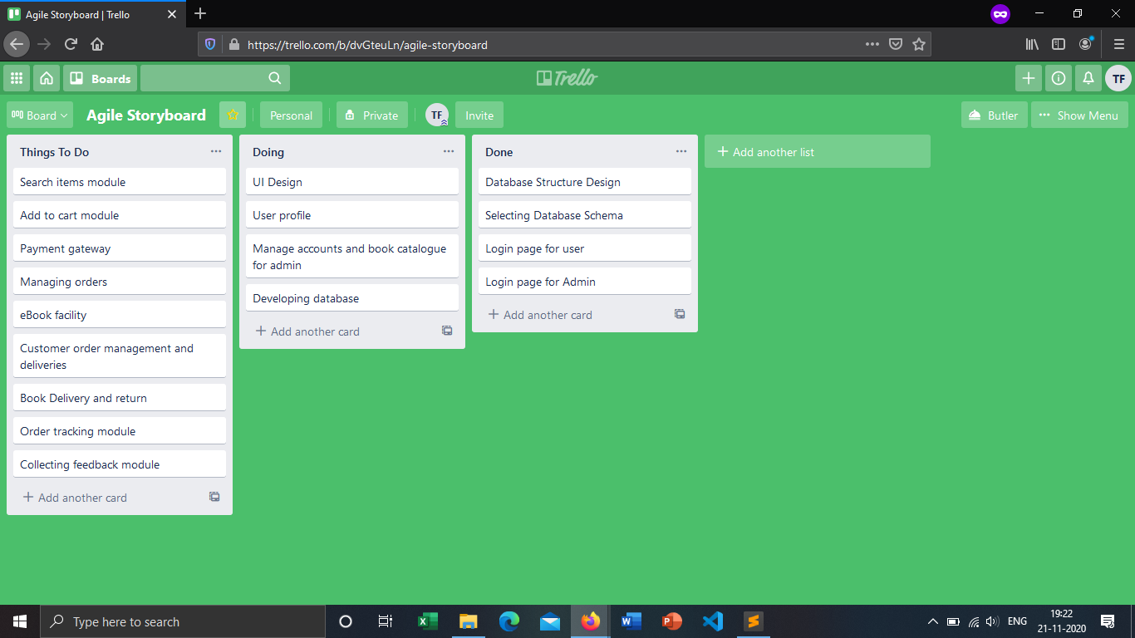

**Release Map**

**Release 1:**

User

* UI Design: - The basic view of the interface.
* Login Page: - Give Security to the user.

Admin

* UI Design: - Interface for the admin.
* Login Page: - Admin Login Page.
* Admin Panel: - Panel to look for site activities.

**Release 2:**

User

* Search: - Give user the option to search preferences.
* Cart: - Give user the review of the saved products.
* Profile: - Give Profile customization options.

Admin

* Manage Books: - Give stock info to the admin.
* Customer support: - Let know of customer queries.
* Payment Platform: - Give payment info to the admin.

**Release 3:**

User

* Orders: - Review the placed orders.
* eBook facility: - Give option to download E-Books.
* Payment: - Give Payment portal to the user.

Admin:

* Increased Booklist: - Add more book to be shown.
* Customer Order Management and Delivery: - Logistics management.

**Release 4:**

User

* Book Delivery and Return: - Give order return option.
* Order Tracking: - Track order status.
* Feedback: - Give Feedbacks for betterment.